Project: **Exploring Weather Trends**

Steps:

1)download world temp data

2)download city wise temp data specific to Pune city by using below query

select city, year, avg_temp from city_data where city = 'Pune'

3)for world temp data we have extra years compare to pune city information

So we will remove some data

We have data of pune city from:1796 to 2013

4)we have few null values in pune city temp data

so we will delete that rows as well from the both csv file.

5)now we will use calculate moving avg for 5 years,10years,15 years

We will use simple math function average.

For 5 years we will take 5 years temperature.

We will do this for 10 years and 15 years.

We will just modify the years in average.

5 years moving average.

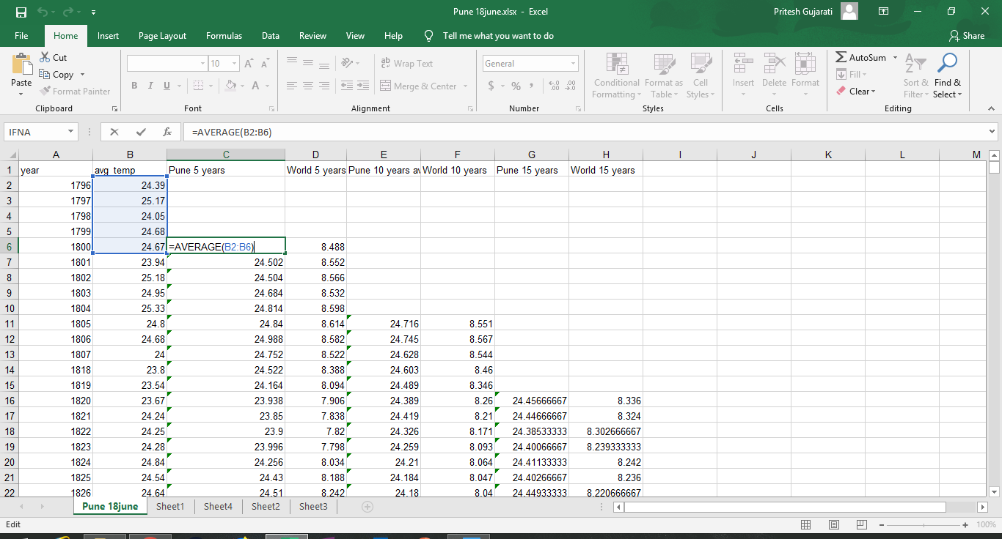

10 years moving average.

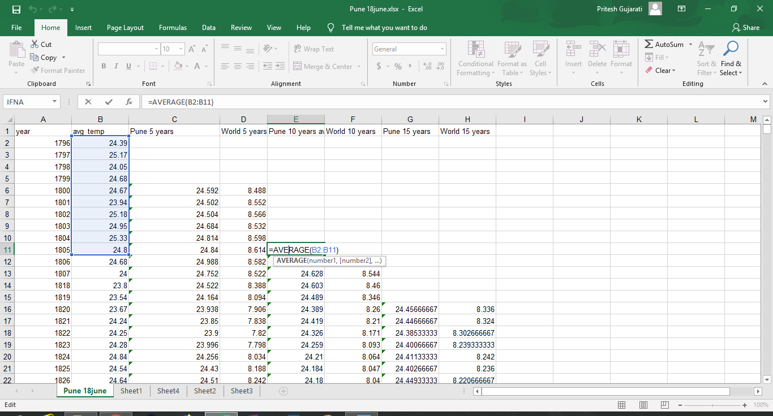

15 years moving average.

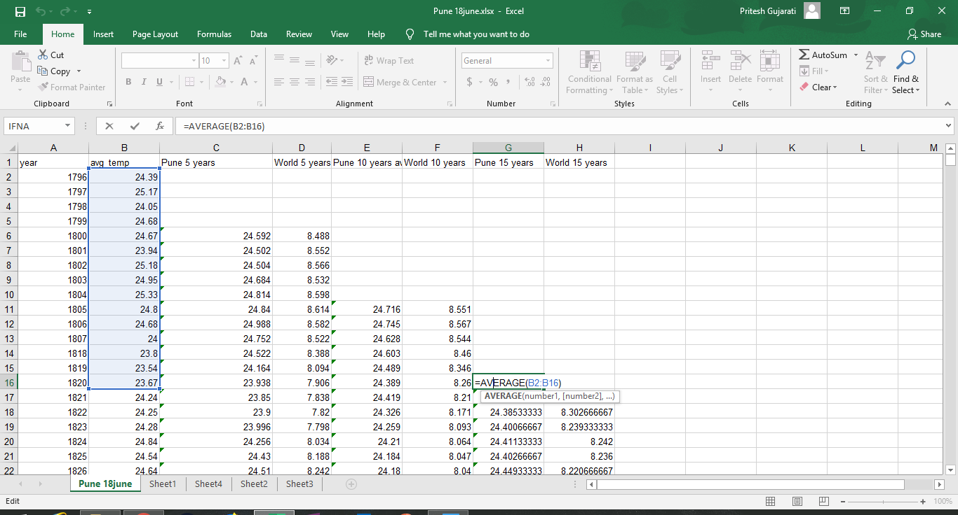

6)we will get moving avg for world temp as well as pune city temp

7)after this we will have 3 graphs

1. with 5 years moving avg

2.with 10 years moving avg

3.with 10 years moving avg

Observations:

1. Pune city and world’s temperature both lines are kind of parallel.
2. As we can see from all the graph the temperature of world and Pune city is increase year by year.
3. Both lines are inclined as temperature is growing.
4. Difference in temperature in Pune and world are:

|  |  |  |  |
| --- | --- | --- | --- |
| Moving avg. | 5 years | 10 years | 15 years |
| Moving avg difference | 15.885 | 15.49653 | 15.10737 |

1. Difference in temperature for Pune and world by years are:

|  |  |  |
| --- | --- | --- |
| Year | Pune | World |
| 1800-2013 (5 years moving avg) | 0.994 | 1.082 |
| 1805-2013 (10 years moving avg) | 0.73 | 1.005 |
| 1820-2013 (15 years moving avg) | 0.966 | 1.168 |